**AD110: USER INTERFACE DESIGN - Capstone Project 4**

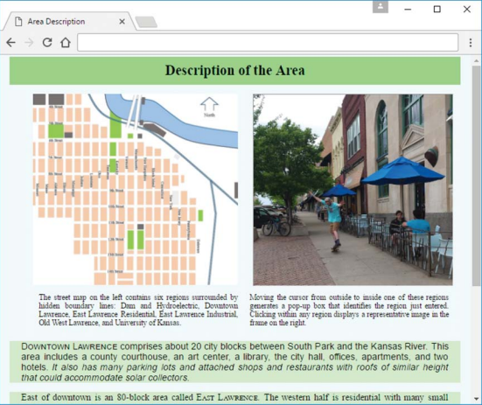

**Using an Image Map for a Small City’s Core Area and Website Navigation with a Generic Home Page**

**Capstone Project Overview**

This course includes an extended example of iterative construction of a website. This website’s theme is a proposed electric-power “microgrid” for the core of a particular small city—Lawrence, Kansas. A microgrid is a small version of a large electrical power network. In normal operation, it provides valued electrical services to local users and the outside world. If disconnected from the outside world, it employs locally generated solar power and previously stored energy to continue providing critical electrical services to local users.

This ongoing case study generates 10 distinct web pages: Electric Power History, Lawrence Hydropower, Area Description, Microgrid Possibilities, Typical Property, Local Energy, Collector Performance, Electric Power Services, Downtown Properties, and Solar Shadowing. For the most part, each of these web pages is developed completely within the case study section at the end of just one chapter. But in some instances, a web page is iteratively enhanced over two or more chapters. For example, the Electric Power History and Lawrence Hydropower web pages are developed separately at the ends of Chapters 1 and 2, respectively, and then enhanced together at the end of Chapter 3. Also, the Area Description web page is developed at the end of Chapter 3, enhanced at the end of Chapter 7, and enhanced again at the end of Chapter 9.

**Capstone Project 4 Assignment:**

Complete Case-Study sections in Chapters 9 - 12:

**Chapter 9: (pp 410 - 415)**

Dynamic Positioning and Collector Performance Web Page A further enhanced areaDescription.html will reposition images as window size changes. collectorPerformance.html will illustrate local JavaScript reading input from a form’s input and select elements and adding rows of data to a table.

**Chapter 10: (pp 483 - 490)**

Collector Performance Details and Nonredundant Website Navigation JavaScript functions will employ if statements, Math functions, and window properties to compute data for the table in the previous chapter’s case study. JavaScript in an external file will improve the website navigation employed in Chapter 6’s case study.

**Chapter 11: (pp 554 - 561)**

Downtown Properties Data Processing properties.html will illustrate use of arrays and objects to maintain a sorted database.

**Chapter 12:** **(pp 610 - 623)**

Solar Shadowing Dynamics solarShadowing.html will illustrate painting of computed geometric shapes on a canvas.

**Submit your files to** **Capstone** **Project Part 4 in Moodle**.

**FOR INSTRUCTOR USE ONLY**

**Grading Rubric**

*Grading accepts a start value of 100. Points will be deducted for failure to fully complete or meet the stated requirements. Grading: 90-100 = Represents work of superior quality (A); 80-89 = Represents work of good to very good quality (B); 70-79 = Represents adequate command of class content (C); 69 and below = Represents work that shows a need for development or improvement (F); 0 = Represents plagiarized work (F).*

**AD110: USER INTERFACE DESIGN (NCP-WEB)**

**Student:**

**Instructor:**

**Date:**

**Capstone Project 4**

|  |  |  |
| --- | --- | --- |
| **Description of requirements** | **Possible Points** | **Your Points** |
| Submitted HTML and CSS files to Moodle | **20** |  |
| Complete Chapter 9 Case study section | **20** |  |
| Complete Chapter 10 Case study section | **20** |  |
| Complete Chapter 11 Case study section | **20** |  |
| Complete Chapter 12 Case study section | **20** |  |
| **TOTAL** | **100** |  |

**YOUR SCORE**: ________

**Instructor Comments:**